**Payroll – LUMP SUM REQUEST PROCESSING**

**DRAFT WORKFLOW MODEL**

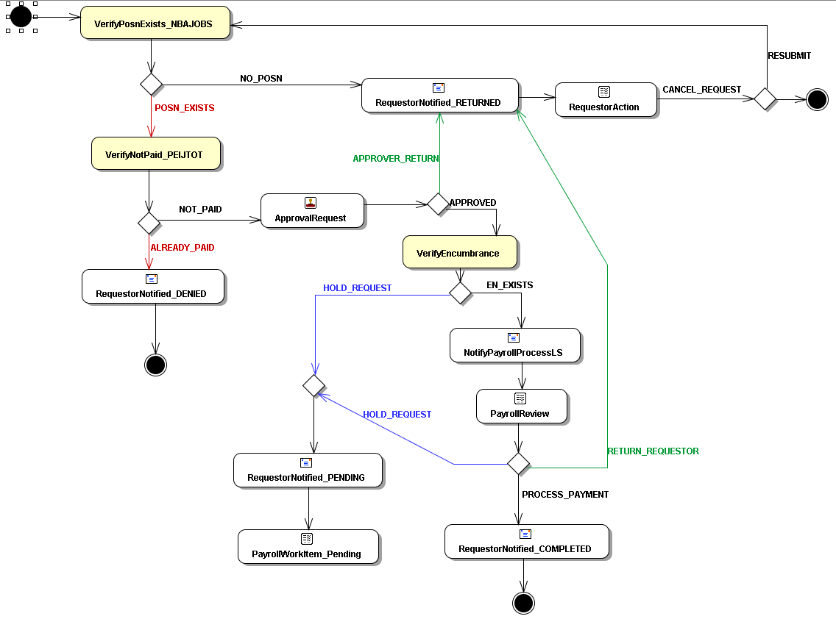

LEGEND:

Yellow Activities = Automated verification of data using code. Will replace current manual effort.

Green Path = Returned to Requestor for Review/Action

Blue Path = Placed on hold/pending. These items remain on PAYROLL’S Pending list.

OPEN:

Need to define what happens when an item is “pending” –

1. Have Workflow End and re-initiate next pay period by requestor
2. Have Workflow End and re-initiate next pay period by payroll
3. Have Workflow sit on PAYROLL’s Worklist until next pay period – need to develop a trigger to remind
   1. The only issue with this is whether or not all prior parts need to be re-evaluated again in which case it should go back through all automated review.